JMeter Test
Load Test for 20,50,100 Request
1)Inventory add (post: /api/v1.0/flight/airline/inventory/add)
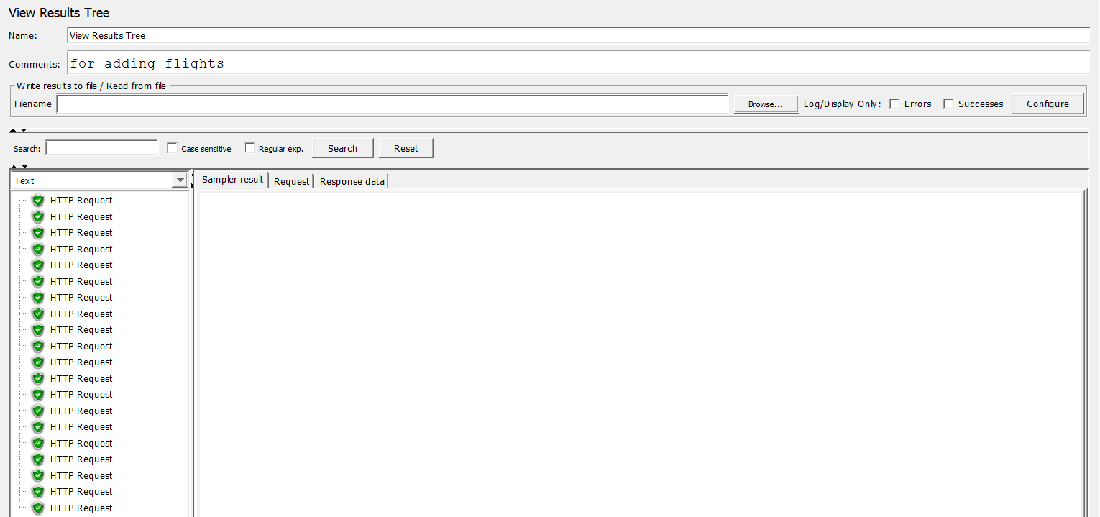
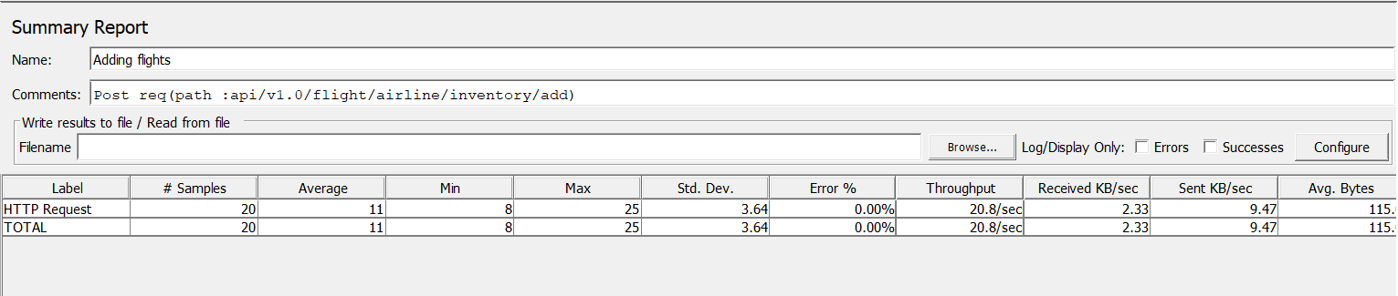
a)20 Threads

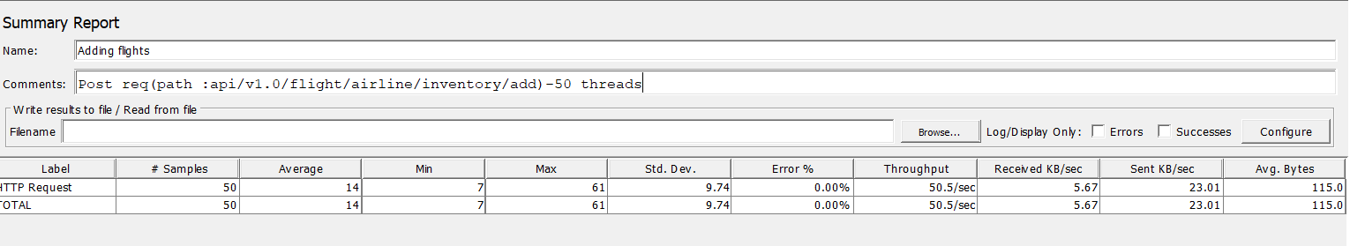
b)50 Threads
c)100 Threads
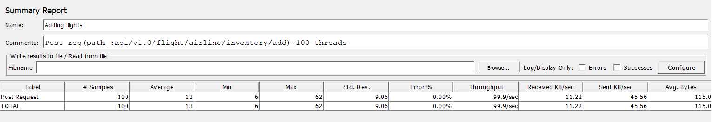
2)Search (post: api/v1.0/flight/search)
a)20 Threads
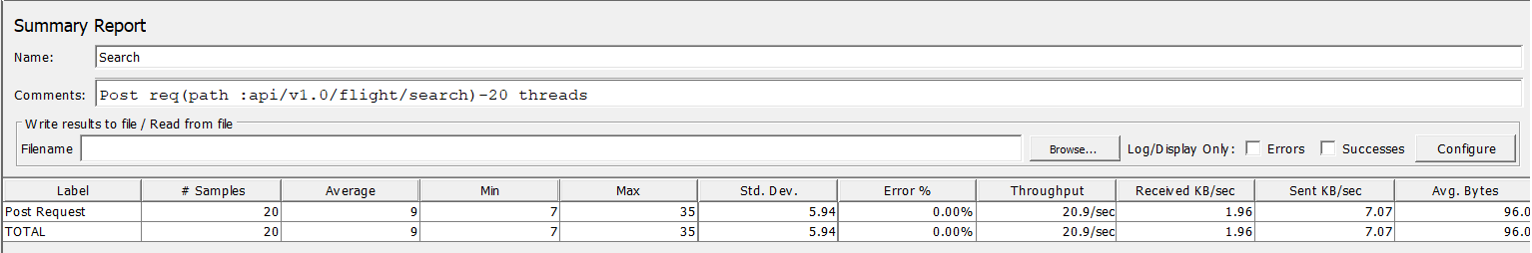
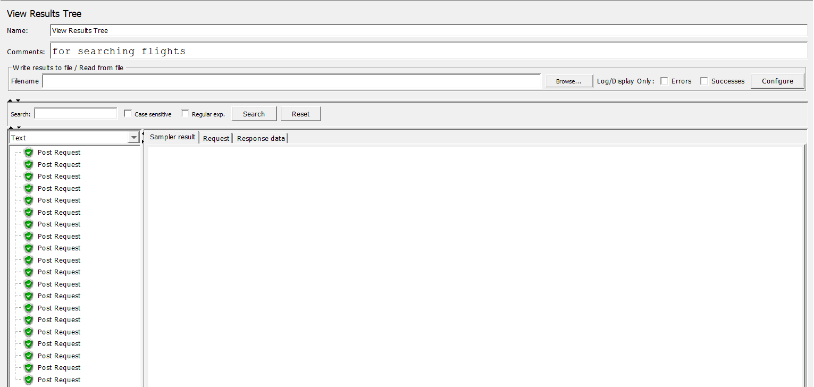
b)50 Threads
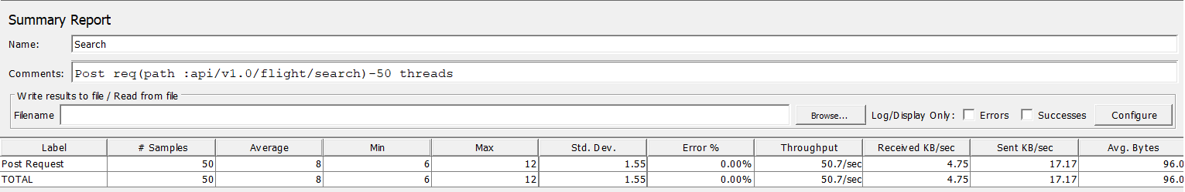
b)100 Threads
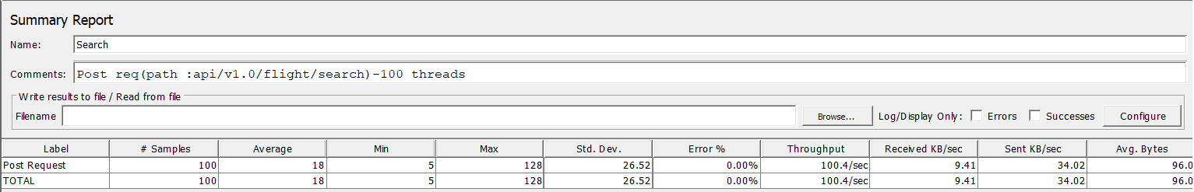
3)Search Airline (post: api/v1.0/flight/search/airline)
a)20 Threads
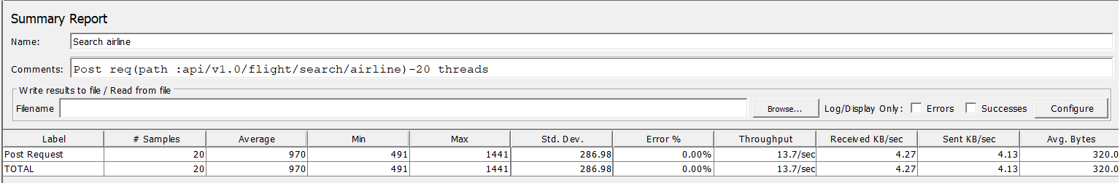
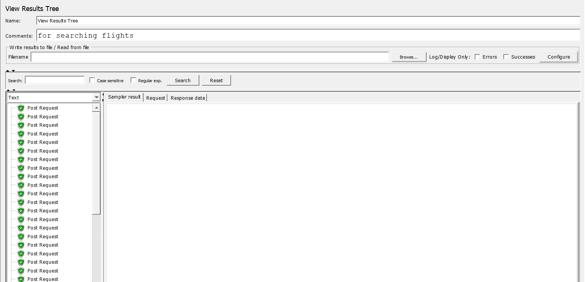
b)50 Threads
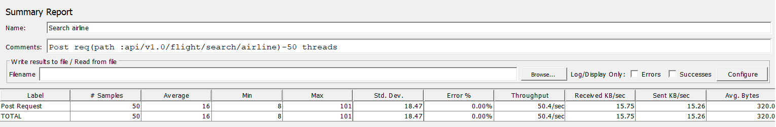
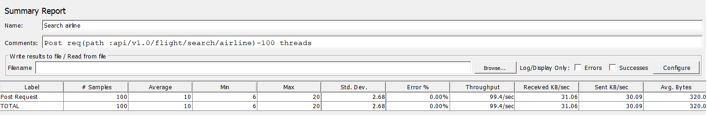
c)100 Threads
4)Ticket Booking (post: api/v1.0/flight/booking)
a)20 Threads
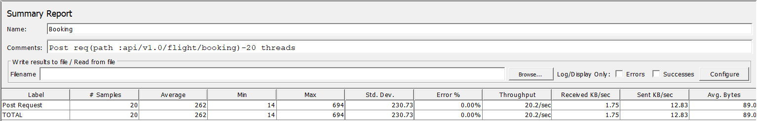
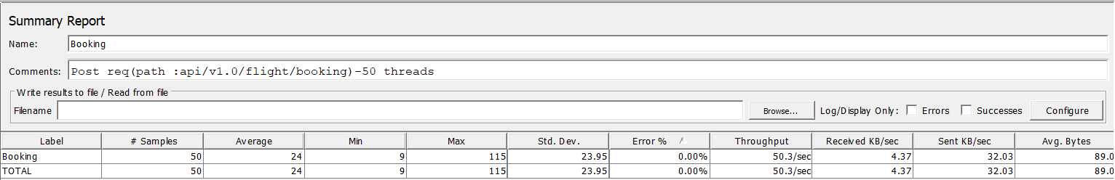
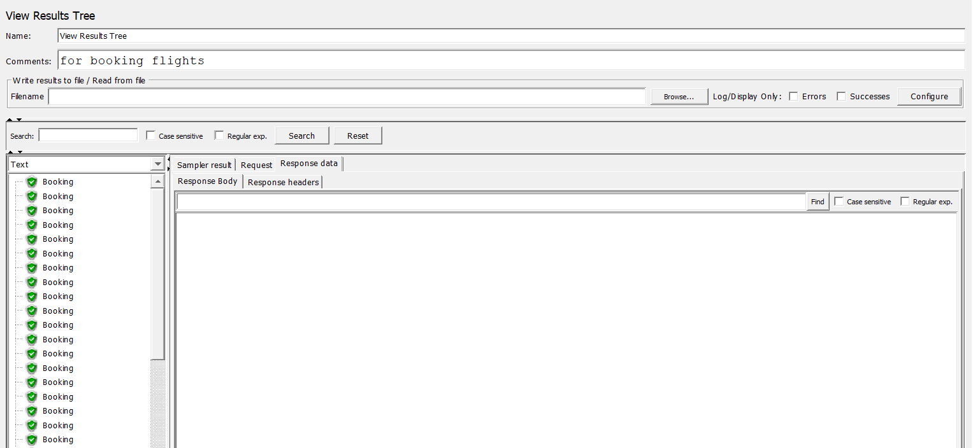b)50 Threads

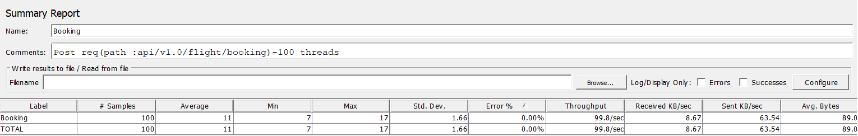
c)100 Threads
5)Get ticket by pnr (Get: api/v1.0/flight/ticket/{pnr})
a)20 Threads
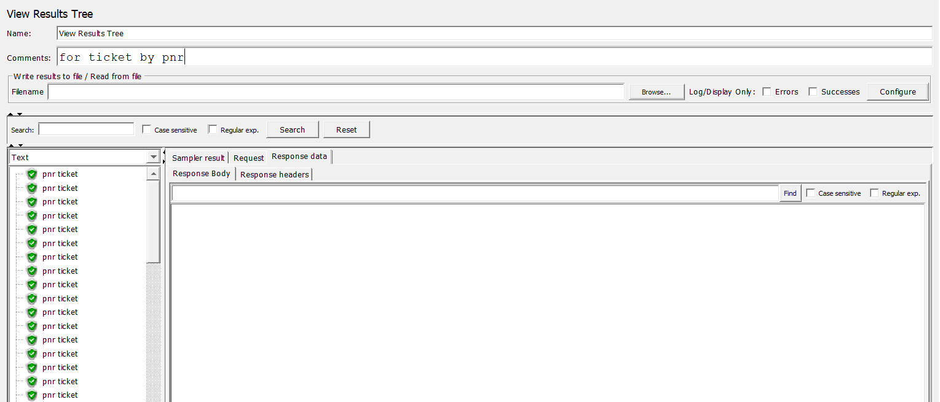
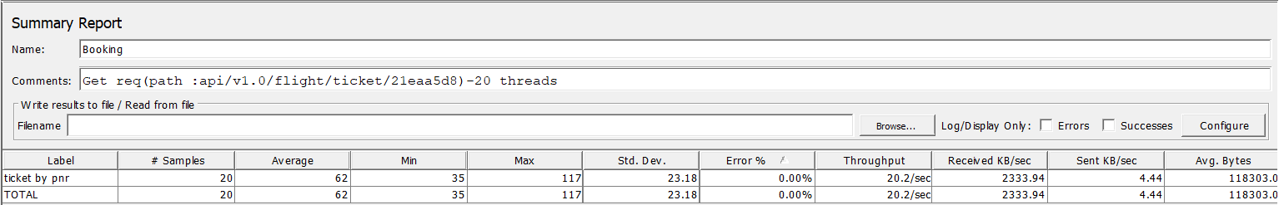
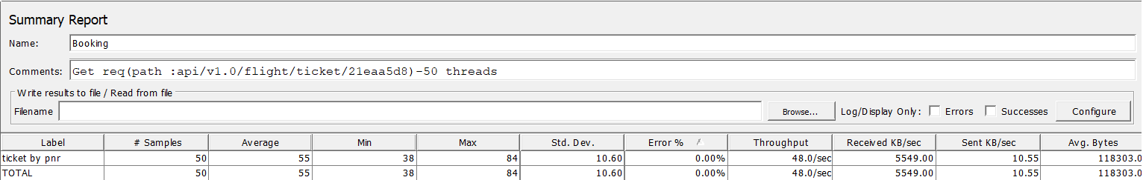
B b)50 Threads

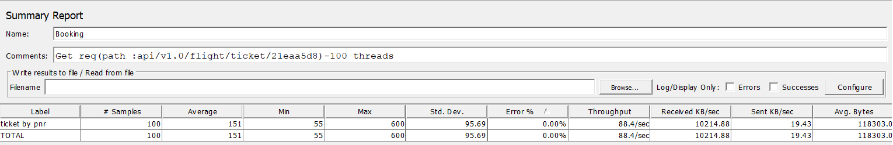
c)100 Threads
6)Ticket Booking by email (Get: api/v1.0/flight/booking/history/{email})
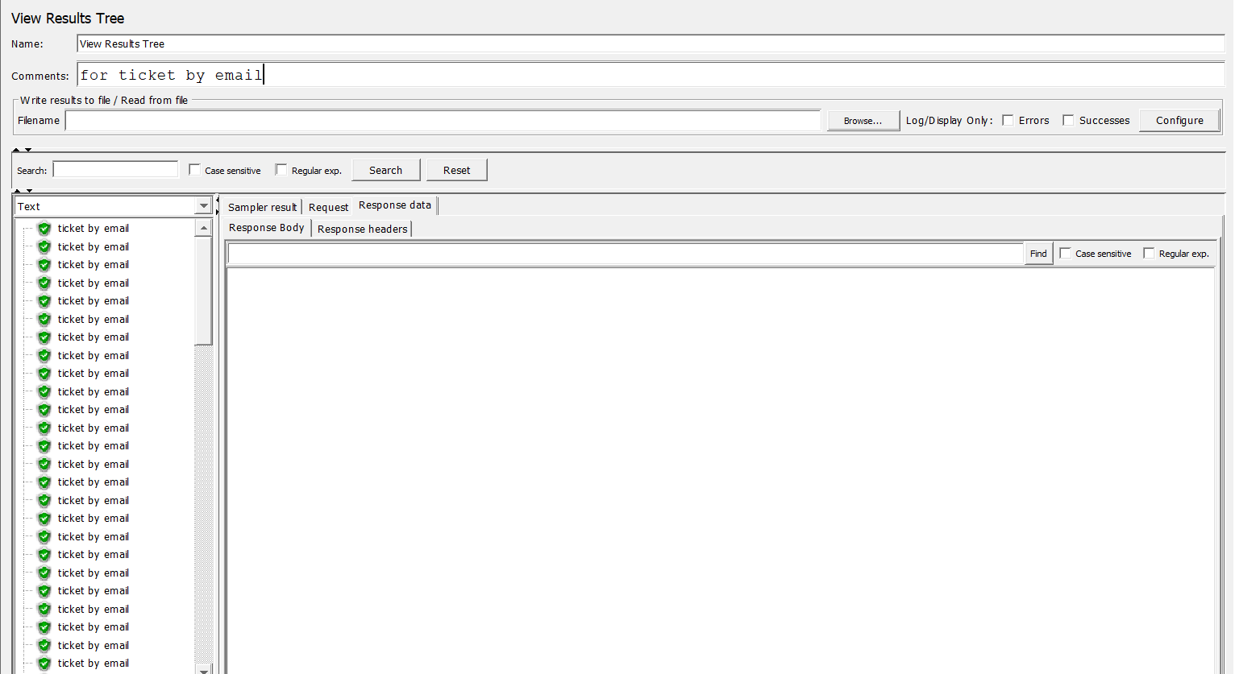
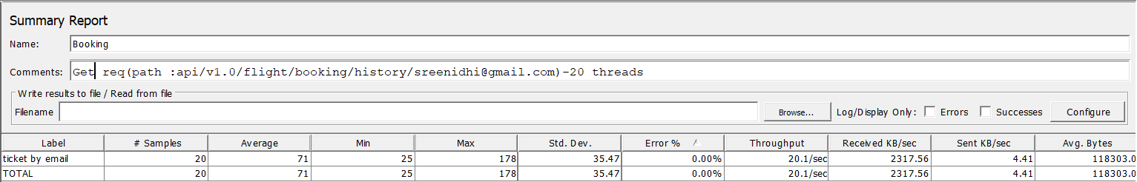
a)20 Threads
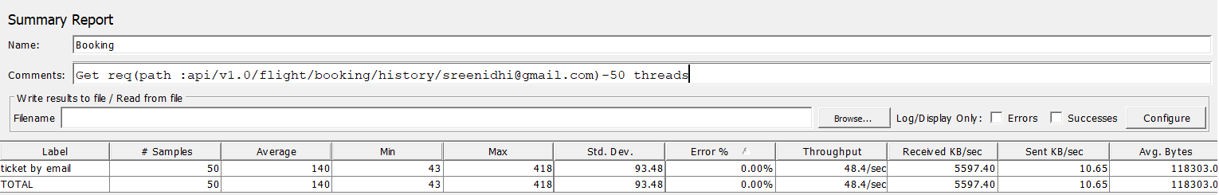
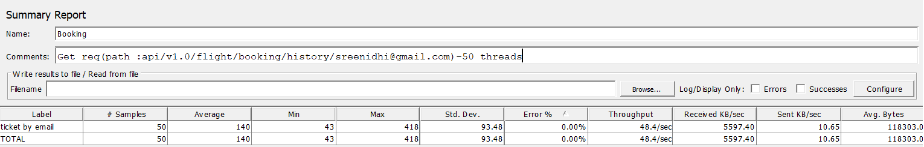
b)50 Threads

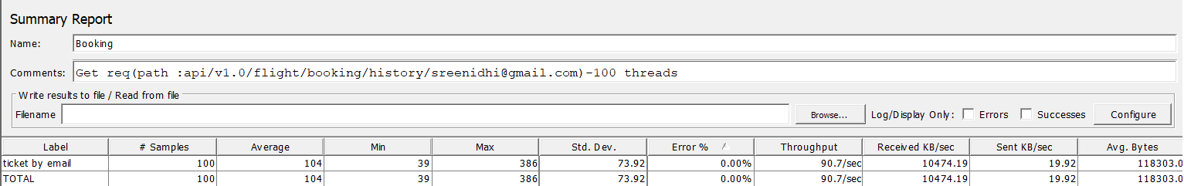
c)100 Threads

7)Cancel ticket by pnr (Delete: /api/v1.0/flight/booking/cancel/{pnr})
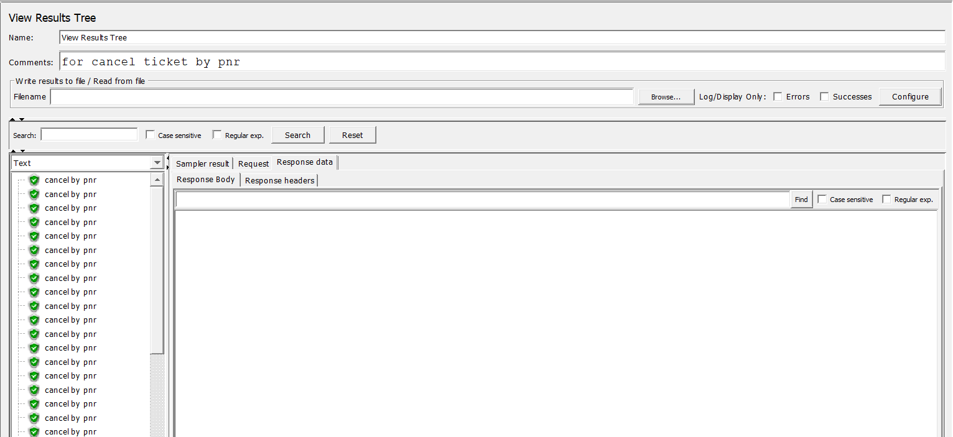
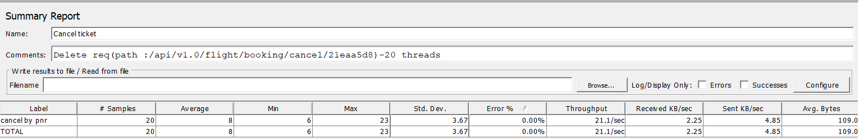
a)20 Threads

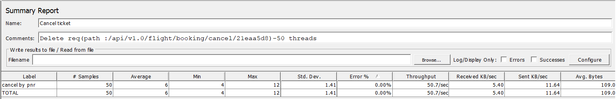
b)50 Threads

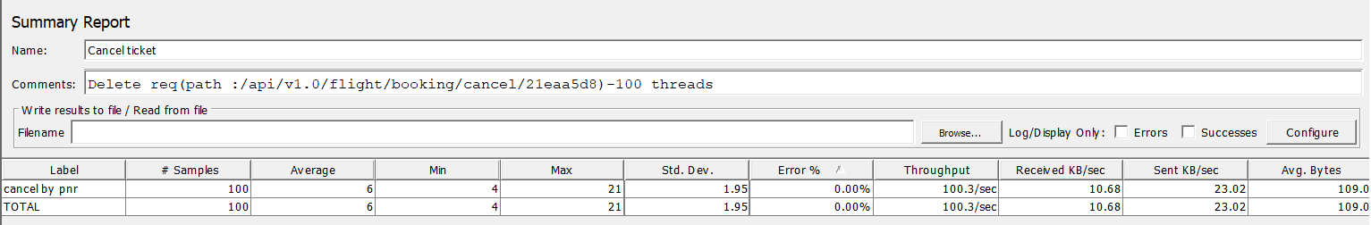
c)100 Threads

c

